

Data Structures and Algorithms -23CSE203
Lab Manual

Submitted By

Submitted to

NAME | K.Naveen
ROLL NO | AV.SC.U4CSE25122
YEAR/SEM/SECTION | 2ST YEAR/ SEM-3/CSE-B
CREDITS | 05

NAME | DR. RAJ KUMAR BATCHU
DESIGNATION | ASST.PROFFESSOR (Sl. Grade)
DEPARTMENT | SCHOOL OF COMPUTING

Index
week |  | Page-numbers
1 | - A rocket launch system displays a count down before launch. Instead of using a loop, implement the count down using recursion. Write a recursive python program to display countdown from n to 1 followed by launch.  - Banks calculate the growth of investment using compound interest. The formula requires calculating powers, which can be implemented recursively. Write a recursive program to calculate P^n where P = Principal growth factor, n = number of years  - A HR department stores employee details in a list. Develop a recursive program to search for a given employee ID. Write a recursive function to search for an employee ID in a list.  - In a logistic department, the no of possible ways to arrange n diff parcels are calculated using the factorial formula(n!). Write a recursive formula to find the factorial of a given number  - Print first n terms in a fibanocci number series
2 | - Write the implementation for the linear search algorithm  - Write the implementation for the binary search algorithm  - Write the implementation for the binary search algorithm along with the sorting the input elements if they are not sorted.
3 | - Write a python program to implement bubble sort where the input elements are taken from the user.  - Write a python program to implement insertion sort where the input elements are taken from the user.  - Write a python program to implement selection sort where the input elements are taken from the user.
4

Lab-1
1a)
Aim:
A rocket launch system displays a count down before launch. Instead of using a loop, implement the countdown using recursion. Write a recursive python program to display count down from n to 1 followed by launch.
Program:
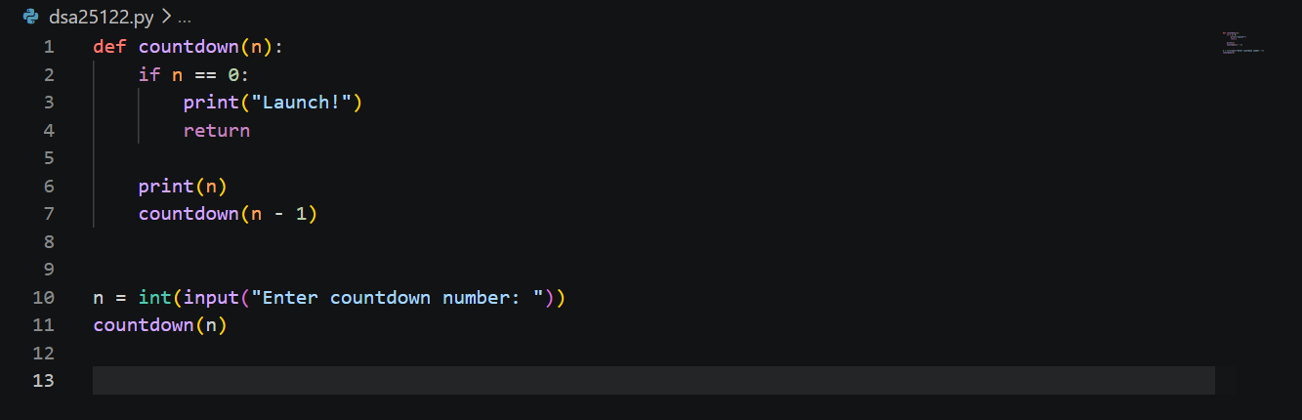
Output:
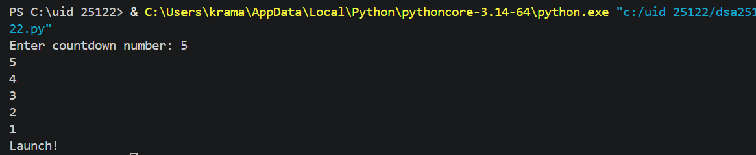
Error Table:
Error | Rectification

Description:
This program uses recursion to display a countdown from n to 1. The function calls itself with n - 1 until n becomes 0, then it displays "Launch".
1b)
Aim:
Banks Calculate the growth of investment using compound interest. The formula requires calculating powers, which can be implemented recursively. Write a recursive program to calculate P^n where
P = Principal growth amount, n = no of years
Program:
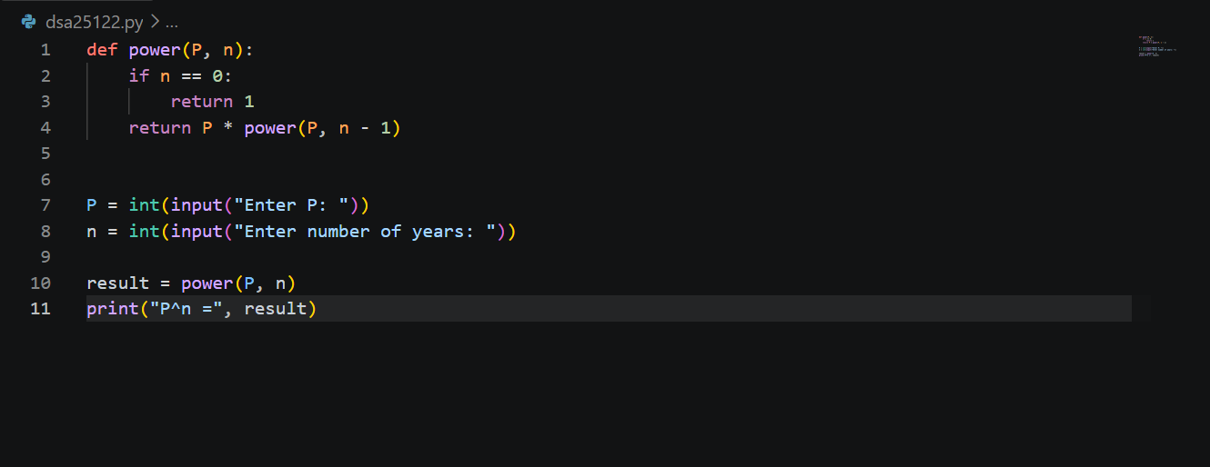
Output:
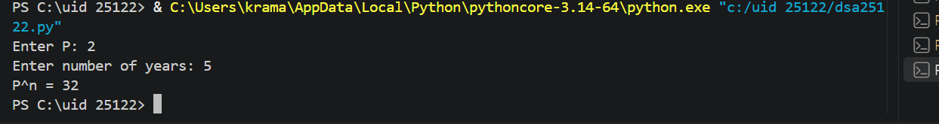
Error Table:
Error | Rectification
Negative values of n were not handled | Added n < 0 condition to handle negative number of years

Description:
The program recursively calculates P^n by multiplying P with the result of power(P, n-1). The recursion stops when n becomes 0.
1c)
Aim:
A HR department stores employee details in a list. Develop a recursive program to search for a given employee ID. Write a recursive function to search for an employee ID in a list.
Program: 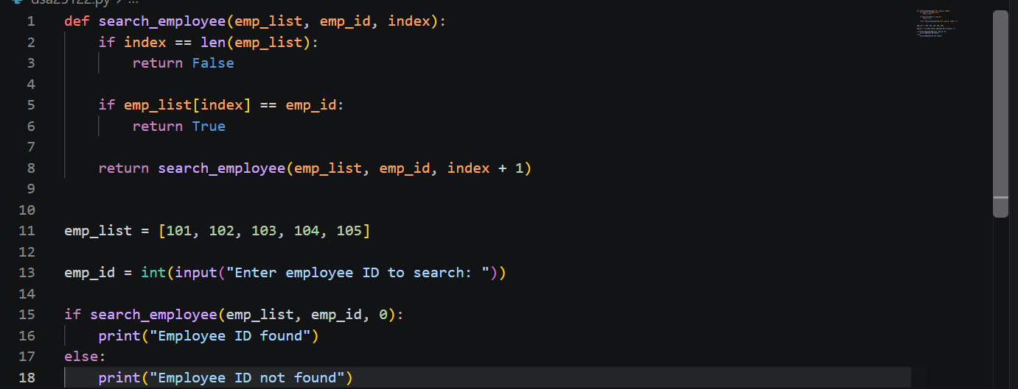
Output:
Error Table:
Error | Rectification
 | Added a condition to return "Employee ID not found"
  Employee ID not found in the list

Description:
The program recursively searches for a given employee ID in a list. It compares the employee ID with each element and continues searching until the ID is found or the end of the list is reached.
1d)
Aim:
In a logistic department, the no of possible ways to arrange n diff parcels are calculated using the factorial formula(n!). Write a recursive formula to find the factorial of a given number
Program:
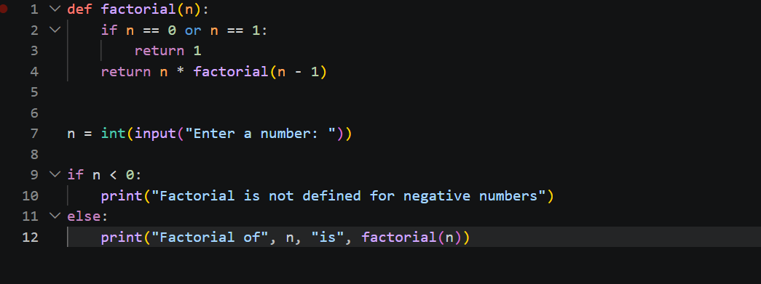

Output:
Error Table:
Error | Rectification
 | Added if n < 0 condition
  Negative values were not handled
Description:
The program uses recursion to calculate the factorial of a given number. The function repeatedly multiplies n by the factorial of n-1 until it reaches the base case 0 or 1.
1e)
Aim:
Print first n terms in a fibanocci number
Program:
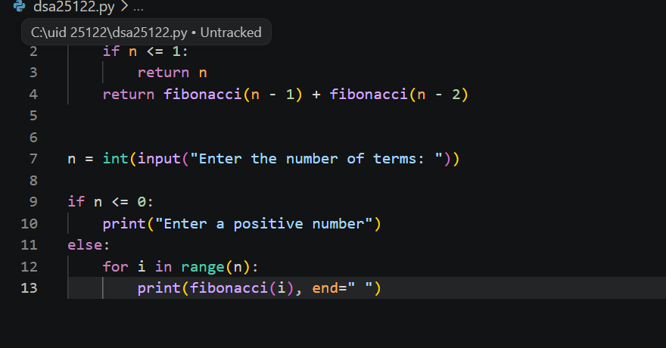
Output:
Error Table:
Error | Rectification
 | Added if n <= 0 condition
  Zero or negative number of terms was not handled

Description:
The program uses recursion to generate the Fibonacci series. Each term is calculated by adding the previous two terms, starting with 0 and 1.

Lab – 2
2a)
Aim:
Write a program for the linear search algorithm
Program:
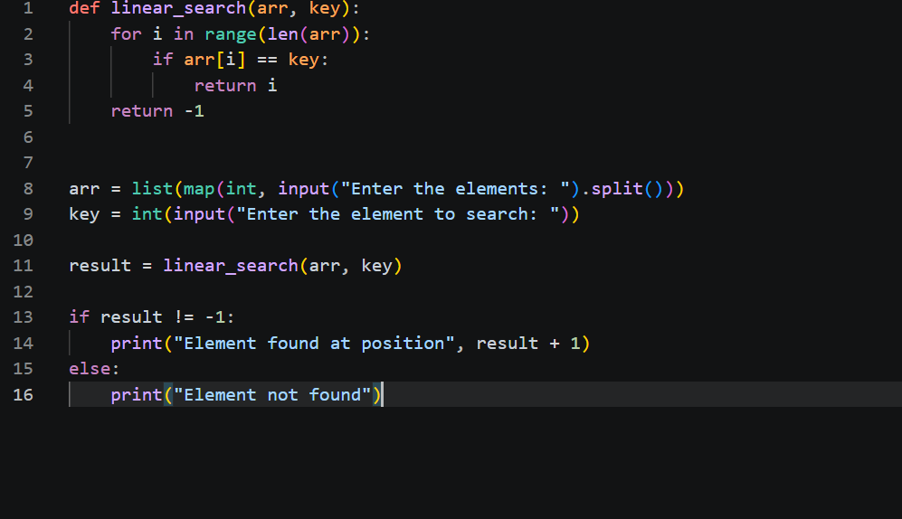
Output:
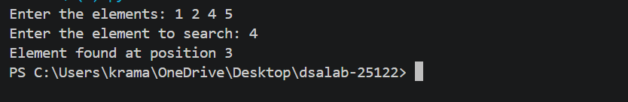
Error Table:
Error | Rectification
  Element not found was not handled
  Added return -1
Description:
The program searches for an element by checking each element of the list sequentially until the element is found or the end of the list is reached.

2b)
Aim:
Write a program for binary search algorithm considering the elements to be sorted
Program:
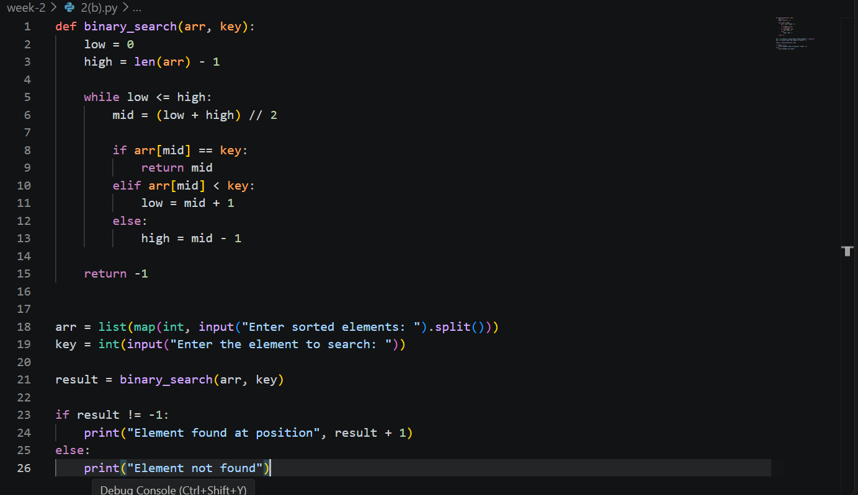

Output:
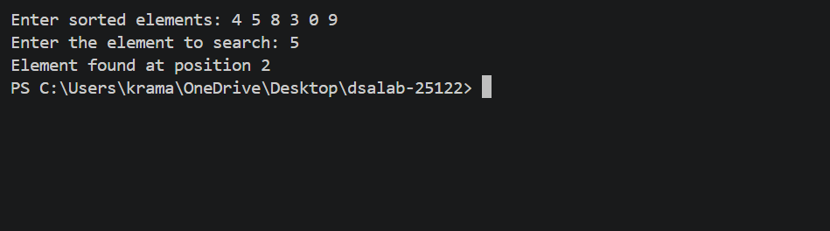
Error Table:
Error | Rectification
Wrote the mid formula outside the while loop which gave the infinite loop error | Added the mid formula inside the while loop
Description:
The program implements Binary Search by repeatedly dividing a sorted list into two halves and searching only the half that may contain the required element.

2c)
Aim:
Write a program for implementation of binary search along with the sorting the elements
Program:
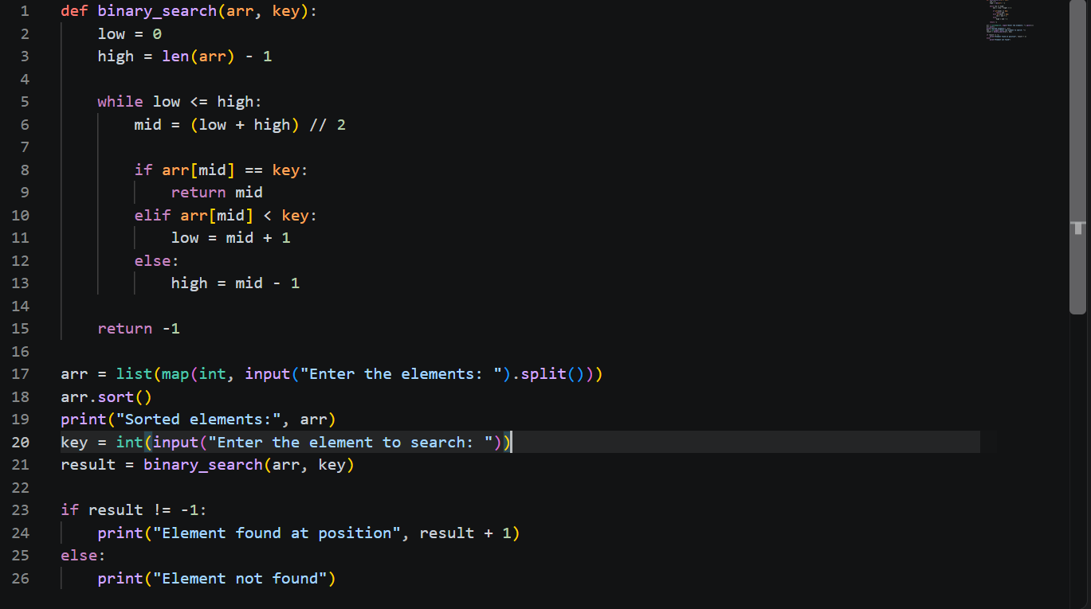

Output:
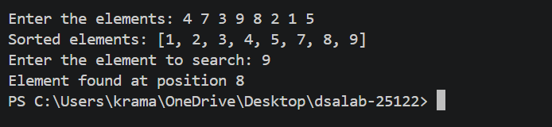
Error Table:
Error | Rectification
Used sorted method instead of which need to be referred to another variable as it returns a sorted array | Used the arr.sort() method which directly sorts the arr without using another variable
Description:
The program first sorts the input elements using arr.sort(). Then, it uses the Binary Search algorithm to find the required element by repeatedly dividing the sorted list into two halves.

Lab – 3
3a)
Aim:
Write a python program to implement bubble sort where the input elements are taken from the user.
Program:
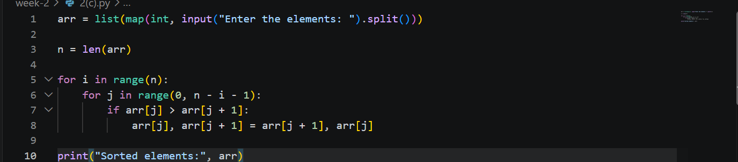

Output:
Error Table:
Error | Rectification
Gave the numbers in descending order | Changed the sign symbol while comparing the adjacent elements.
Description:
The program implements Bubble Sort by comparing adjacent elements and swapping them when they are in the wrong order. This process is repeated until all elements are arranged in ascending order.

3b)
Aim:
Write a python program to implement insertion sort where the input elements are taken from the user.
Program:
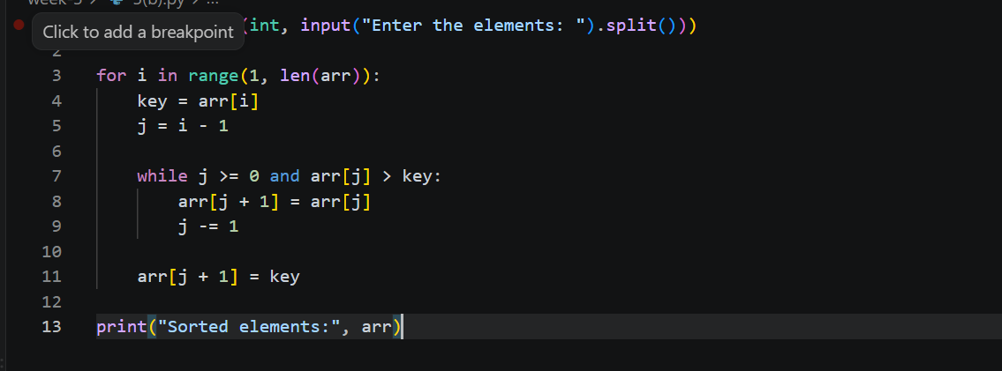

Output:
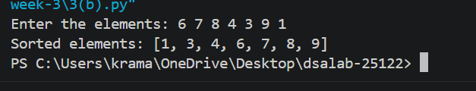
Error Table:
Error | Rectification
Description:
The program implements Insertion Sort by taking one element at a time and inserting it into its correct position among the already sorted elements.

3c)
Aim:
Write a python program to implement selection sort where the input elements are taken from the user.
Program:
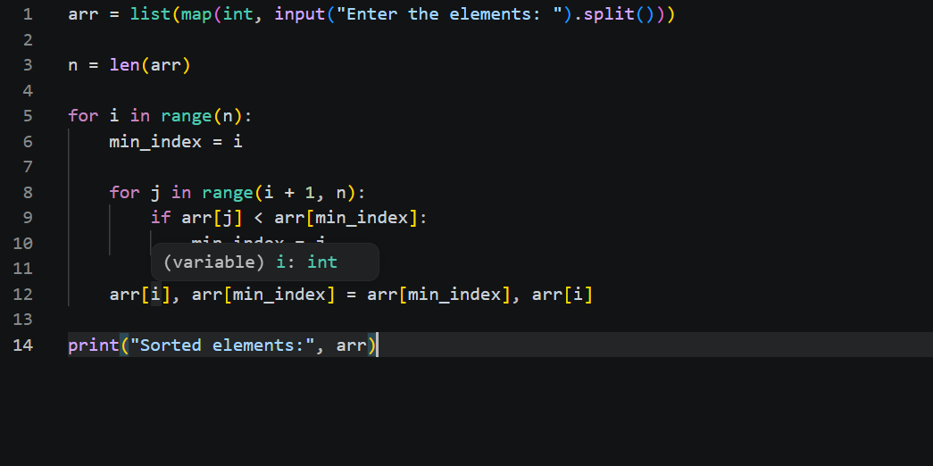

Output:
Error Table:
Error | Rectification
Description:
The program implements Selection Sort by finding the smallest element from the unsorted part of the list and swapping it with the first element of that part. This process continues until all elements are sorted in ascending order.

